Useless Lock Box

ECE411 – Practicum Project Proposal

Team Members: Daniel Diaz, Dwayne Hoeck, Le Thanh, Ha Tran

Our team has decided to pursue the useless lock box as our practicum project. The useless lock box will be a combination of a useless box and a lock box.

The useless lock box will be a box with a switch on the top, and an LCD screen and keypad on the front. You will flip the switch on the top to enable the LCD screen and keypad. When the pre-programmed code is entered into the keypad a “secret” compartment under the keypad will open for someone to store valuables. If the code that is entered into the keypad is incorrect an arm will appear from the top of the box and flip the switch, disabling the keypad. The screen will show the keys as they are being pressed and display a satirical message on the screen when the code is incorrect.

The prototype will be made out of either wood or soft plastic but could be expanded to metal for better security. For this project we will be using the following materials:

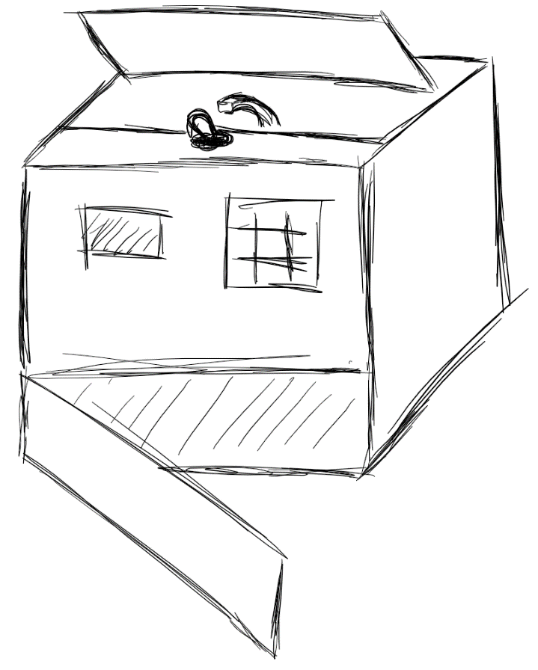

Figure – Concept Drawing

**Sensors:** Toggle switch

Digital keypad

**Actuators:** LCD screen

Motor

Solenoid (locking mechanism)

**Processor:** 8-bit microcontroller